**Grade One Phonics Worksheets**

**Monday May 11th, 2020**

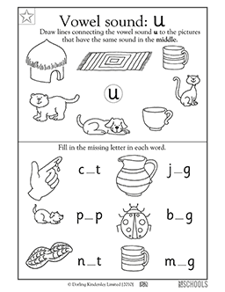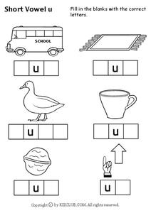

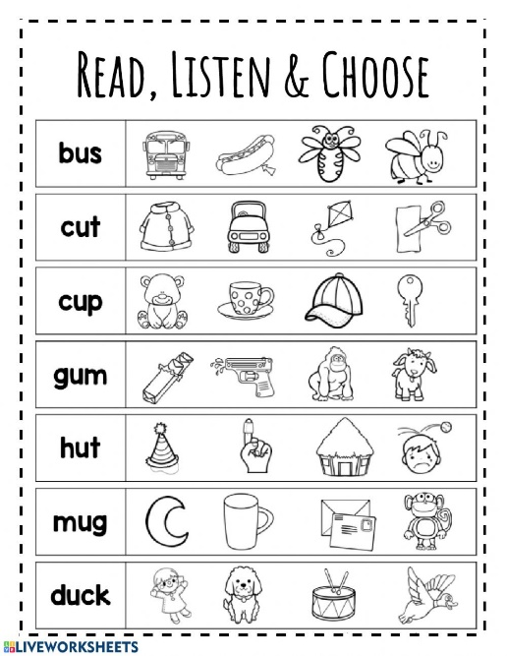

Grammar Worksheets for Grade One

Wednesday May 13th, 2020

Read the sentences. Put a tick in the box next to the sentence that ask a question.

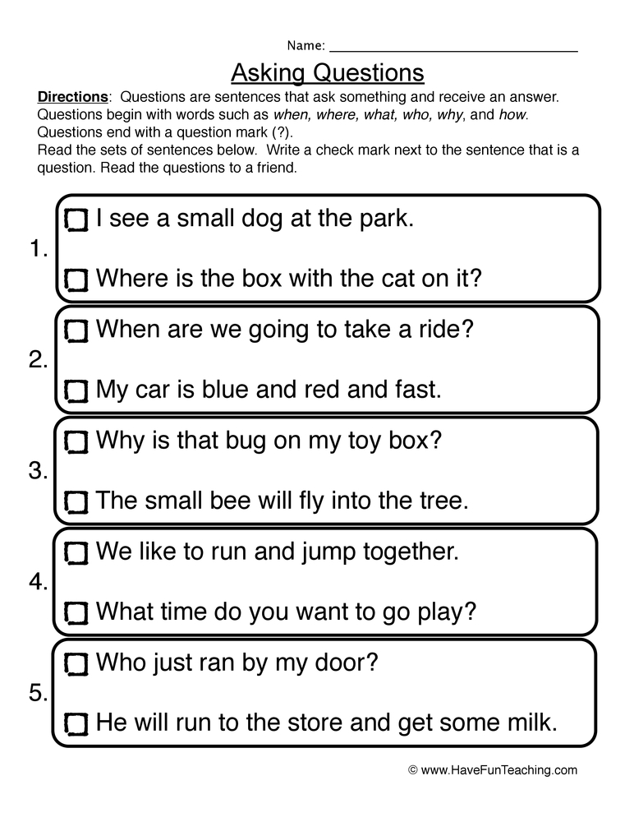

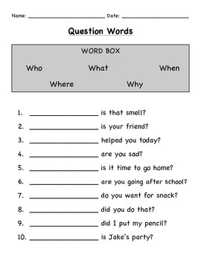

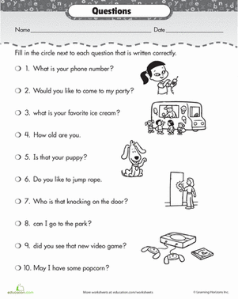

**Spelling Words Grade One**

**Money, time, after, book, wish, stay.**

**Friday May 15th, 2020**

**Assessment Exercises**

